Knife Sharpaning Guide

Table of Contents

​ Inspirations and Ideas 1

​ Learning New Tricks 2

​ PCB Design 2

​ SMD Soldering 3

​ Arduino 4

​ 6

​ G-Code Editing 6

​ To Assume or not Assume 7

​ Pulling all the Stops often Leads to Crashing 7

​ Circuit Blocks 8

​ Data Direction 9

​ Scanner and comparators 9

​ Shift registers and 2-stage clock 9

​ Output data compressor 10

​ The Gantry 11

​ Amost Putting it Together 11

​ Keep it Simple Stupid 12

​ The Reason I Love Math 12

​ Making Discoveries 13

​ Which way is Up? 19

​ Revisiting, if I Felt like it 21

Workd Cited 23

​ Contact Information 25

​ Project Information 25

# Inspirations and Ideas

Having recently finished building, setting up, and toubleshooting my PC (admist the GPU shortage: 1050Ti was the only reasonably priced one available), I figured starting a neew project should be my next step. Get to prevent my electronics skills from getting rusty, find all the productivity programs I need to install, and to curb my abject and growing bordem.

On the side, I was also learning my way around the kitchen which of course includes keeping all the knives sharp. Noticed they began dulling, so I took out my grindstone set hoping to rehone the edges; grind, wash, grind, wash, repeat, repeat, paper test… still made the cut, but not as smooth as I hoped *and* done better after a previous session. Huh.… Had a good, disatisfiedpeer down along the edge, the light just about catch the bevel’s curvature. Go figue I messed up my grinding angle, damn thing is suppoded to be flat….

*“Why not make something calculate the angle for you?”* rightly spoke the engineer in the back of my mind. *“All I needed was to display the tilt of the knife somehow, it will be a fun warmup!”*

The project lasted from the April 20th 2021 to the October 11th 2021: total project time 15 days and .72 hours.

# Learning New Tricks

Given the small scope of the project, I snuck in lessons on PCB design and SMD soldering, exposing myself to the Arduino's more advanced features, and peeking into a 3D printer's G-Code. Figured I should at least take the ample time I had to start familiarizing with more advanced topics.

## PCB Design

While searching for a PCB design software, I happened onto YouTuber Robert Feranec — recommending KiCad as a capable program1 — with hour(s) long videos dedicated to upping tour PCB design2. I binged as much as I could bear in my free time and barely understood much past 'have an unobstructed ground plane' and 'keep your traces short and neat'; granted most of the advice actually matters in high frequency switching circuits, but I gotta dip my toes in at some point. The topics on circuit inductance were pretty neat…3, 4. (*“Is KiCad Ready to Replace Paid PCB Design Software? (with Wayne Stambaugh)”*)1, (*“How to Improve Your PCB Layout - Routing & Space”*, 6:00-8:10)2, (*“EEVblog #742 - Why Electrolytic Capacitors Are Connected in Parallel”*)3, (*“EEVblog #1323 - PCB Layout Review & Analysis”*)4.

Figure 1: KiCad is a basic, free PCB designing program compatable for Windows, Mac, and Linux.

Designing PCBs kinda slaps though: creating and having a circuit diagram at the ready is incredibly useful: had a blast jigsaw-piecing the components around: got to create a footprint for a SPST switch. Then I needed the boards manufactured, gotta shelf my project and waste the better part of a month each time I needed a board. Forgot to ground my buffers, was not willing to wait a whole another month for a small mistake; drilled a hole to the ground plane instead.

Would be nice to set up a PCB fabrication instead, doubt the apartment complex would appreciate renovating a room to a lab. Next best option would be to fork out an extra $100 monthly for a space I will barely use otherwise… someday maybe.

## SMD Soldering

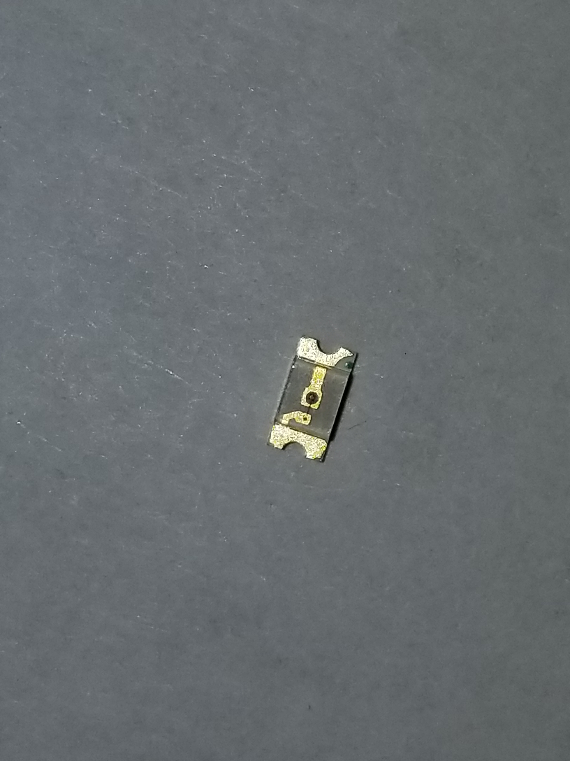Figure 2: Yup, the miniscule cathode marking on an already small 1206 LED (0.12”x0.06”). Probably should have done the quarter thing... but I'm too lazy and the internet already had loads of those pictures already, so go look it up.

Already designing PCBs, so why not dip my toenails in SMD soldering as well? Ordered the parts I needed for my project along with some SMD to THT breakout boards for practice — gotta pay attention to the pad size — and pulled up soldering tutorials on YouTube, one by 'EEVlog'5, another by 'GreatScott!'6. Admittedly, I don't think I have the whole process down yet. Feel like I'm using too much flux. The soldering iron tips I got are a bit too big, or small, and probably not the right shape for tapping down the incredibly small pins. And the tweezers I own do not work well with SMDs, twisted my wrist at an awkward angle to keep the chips at the proper position: minding my pinch strength to *not* eject those tiny pieces into the carpet. LEDs especially gave mw headaches, the mark for the cathode can barely be spetted by my naked eye; there were no markings whatsoever indicating which LED is which color. Got creative and pressed the components on some pads to light them up, minding not to send them flying off. The things I do for aesthetics. (*“EEVblog #997 - How to Solder Surface Mount Components”*)5, (*“How to Solder Properly || Through-Hole (THT) & Surface-Mount (SMD)”*)6.

## Arduino

I first tried the obvious choice of the MX2125 acceleration sensor which was advertized to also indirectly sense tilt. In a brief test, any jostling I performed reflects in the output, so any tilt calculations might come out reliable either. Tried the L3G4200D believing a sensor labeled a 3-axis gyroscope would hand over tilt data — lucky, lucky for me, it was *also* in acceleration, and didn't appear fast nor sensitive enough to provide accurate tilt changes. Curious and still building hope, I opened up the Adafruit_Sensor class library — parsing through the files made much less daunting by my brief trial into C++, I spotted a member labed “orientation8”. Hopes raised, I searched 'arduino orientation sensor', double-checking for the same chip to appear in the search results. No, but the BNO055 showed up instead; saw the off kilter bunny on Adafruit's overview on the sensor, capable of displaying 360° of tilt for all 3-axis. It was perfect, and out of stock for three weeks. (*“Adafruit Unified Sensor Driver”*, line 128)7, (*“Adafruit BNO055 Absolute Orientation Sensor”*)8.

I grew fed up having to create new constructors for every function using the ILI9341, but a lot of memory would be wasted if I created another function just to store all the text. Remembering that Arduino code is not only similar to, but can also run on C++ based on the library code. In C++ if an object constructed within a class, the methods can share the same object, thus only needing to create one object. While I did eventually learn how to store an object in a class, I needed to dig deep into some Arduino forum posts, and then linked to a separate website just to learn the slightest difference in setup; you can't construct the objects within the class constructor, has to be done in a method. The Arduino website really should have mentioned such a quirk somewhere, probably make the day of a lot of people.

## 

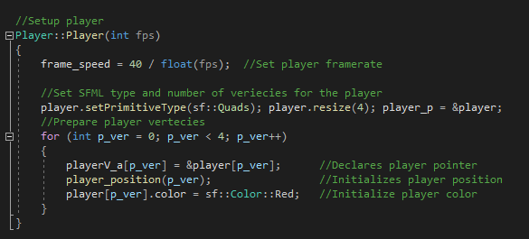Figure 3: Yeah, I normal C++ I can just place my object contructor in a class constructor, but NO Arduino has to be difficult for no apparent reason.

## G-Code Editing

Nothing too drastic here honestly, I knew ahead of time that pausing and resuming a 3D print is possible. So I designed the knife clamp to embed some magnets, pulled up the video I saved by 3D Printing Nerd about embeding magnets into 3D prints9. Edited the g-code as instructed, and let the printer do the rest of the work. Pretty proud of the design, can easily de/attach the BNO, and it sticks on well enough — another set of magnets and another alignment key would make it perfect! (*“Embedded Magnets Thanks to Flipping Normals!”*, 11:40-14:00)9.

# To Assume or not Assume

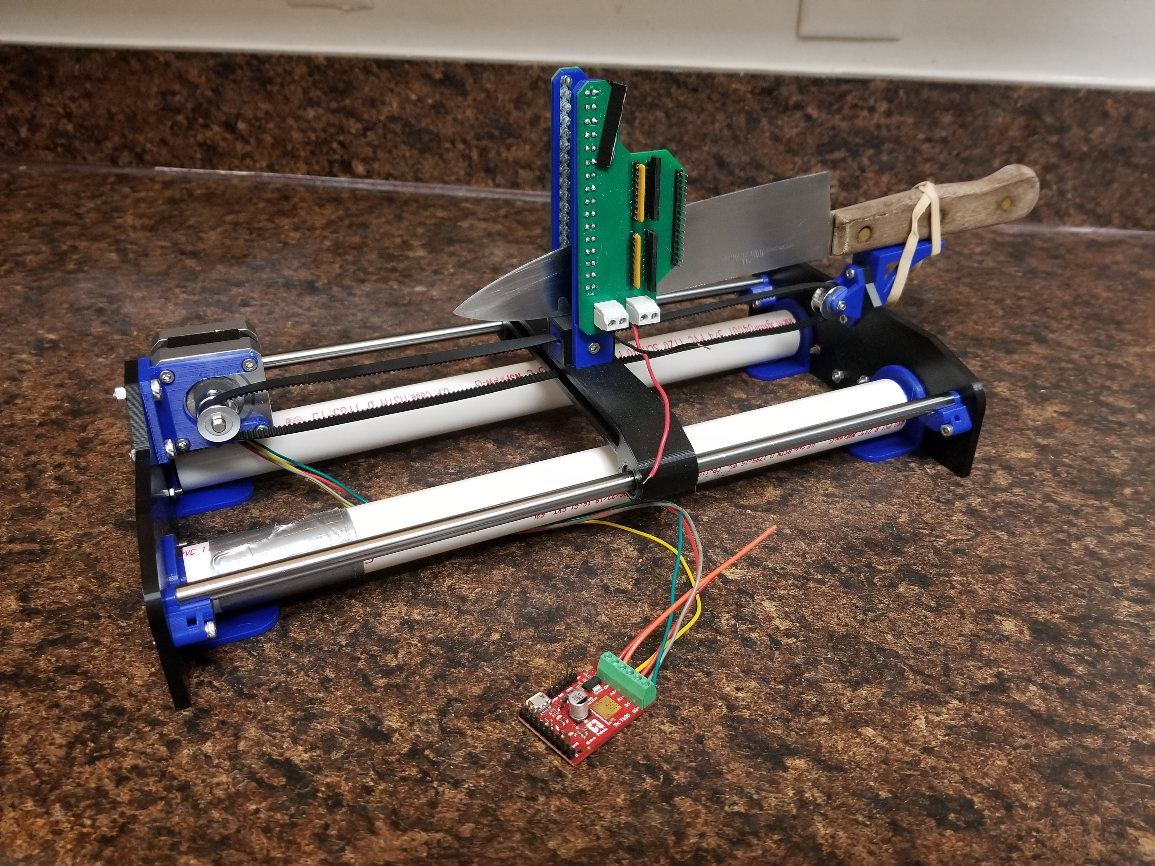Figure 4: Attempt #1. Fancy looking, 3D printer like… thing. Never got around to see if it will move, but I am mostly positive it would have worked.

## Pulling all the Stops often Leads to Crashing

First round of theorizing and planning: figured out angle of the sharpening angle is perpendicular to the tangent line of a point on the edge, was only flipping weather or not I need to know where the knifr touched the grindstone. Cautious I am, I assimee I needed to know and spent a good month and a half designing everything within this section. Long story short, I found what I assume to be the Arduino's memory limit and had to scrap a month and a half of work.

Everything below still holds some interest in its own right, though feel free to skip to *Keep it Simple Stupid* below for the successful solution.

### Circuit Blocks

Gameplan: use photo sensors to read the knife's profile, somehow feed the data back into the Arduino to be saved into an SD card. When sharpening the knife, read the profile data, display the shape on a screen, then read the tilt of the BNO to point to the edge being sharpened; read the locations around the edge to approximate the slope and calculate the angle from there.

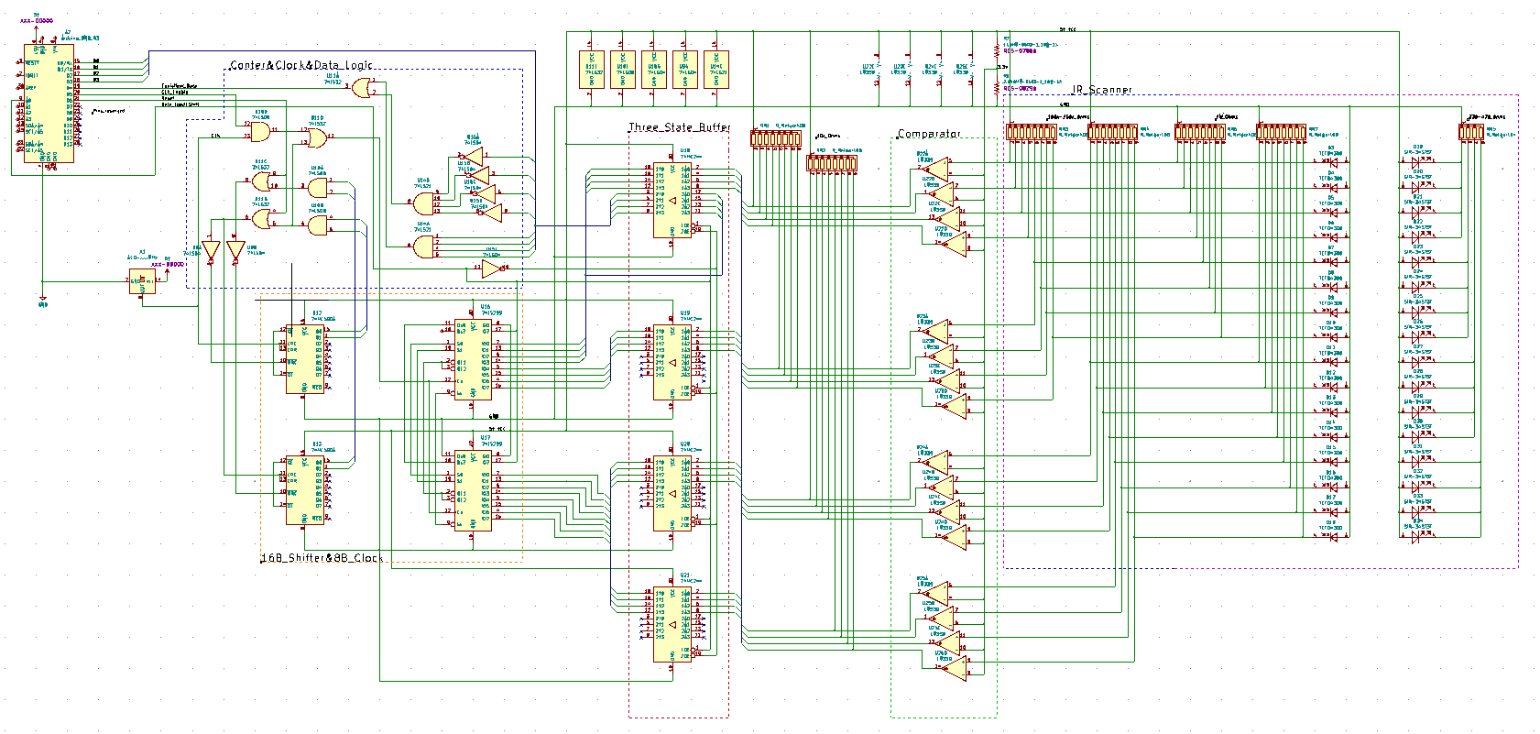Figure 5: Circuit diagram for the scanner and data converter. Since I can barely see what's what myself, I will provide the circuit file.

### Data Direction

A NOT-gate controls the direction the data flows around the circuit. Wioth the input set to 0V LOW, the tri-state buffers sends the input data from the photo-scanner into the shift registers set to LOAD: on 5V HIGH, shift registers change to SHIFT mode, sending data towards a compressor (is supposed to be) read by the Arduino.

### Scanner and comparators

To minimize edge contact and keep the mechanics somewhat simple, a line of infrared LEDs would emit to another line of reverse-biased photodiodes. The knife fits between the gap, causing the output voltage of the diodes to rise. The photodiode voltage inputs into an array of comparators — the LM399 on this case — bumping the voltage either up to 5V HIGH or down to 0V LOW.

### Shift registers and 2-stage clock

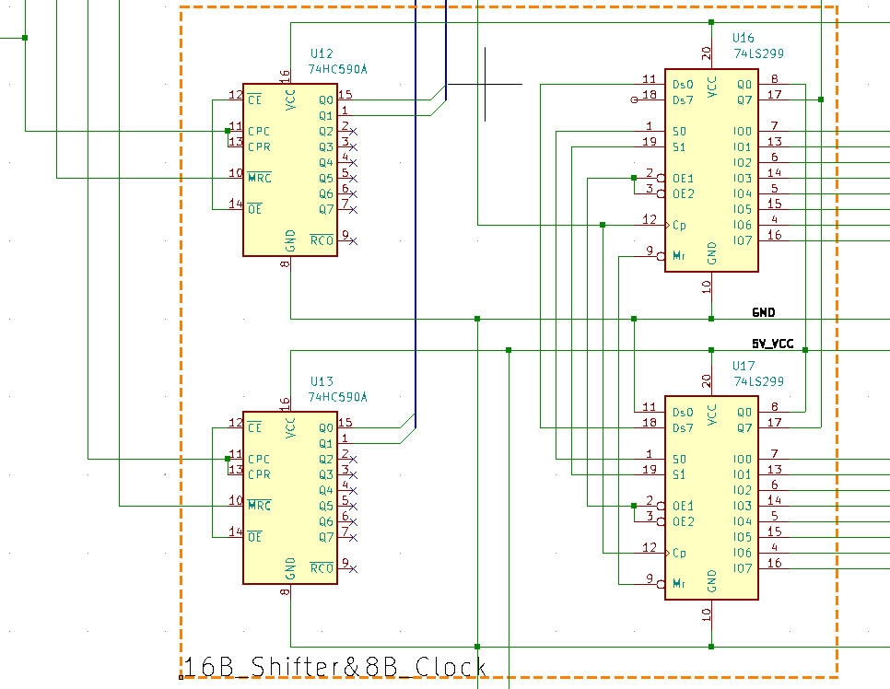Figure 6: The counter controlled shift register. Gotta say, I am still 100% proud of myself for coming up with this circuit.

The SN74299 shift registers manage the scanner data allowing the Arduino to save on input pins by breaking the stream into equal sized chunks. The 2-stage, SN74590 counter controlls the registers’ bit shifting; the Least Significant Counter (LSC) controls the number of bits shifted at once, intended to be controlled directly by the Arduino only to shift when it's ready for the next chunk of data. The Most Significant Counter (MSC) tells how many sets of bits are available and left to read, incremented each time the LSC shifts bits. The counter resets upon reaching the number set. Example, if the scanner inputs 32 bits of data and I want to send it in sets of 4 bits, the LSC would shift the register up by 4 and the MSC only allows 8 shifts to occur: essentially 4 bits/shift * 8 shifts = 32 bits. There is a quirk with the [counter IC name] however, on reset the chip outputs a 'don't care' needing one clock cycle to output a zero which eventually threw off the shifting as the circuit ran. So I made the registers skip the 'don't care' state by [need the logic to decide when the DC is active] combining the HIGH cycle of the clock. For the LSC, the clock signal remains unaltered allowing the IC to set its output to zero.

### Output data compressor

So the plan was to increase the scanner's resolution after the scanner, code, and angle calculation (theoretically) got working, I had concerns about the read time getting much longer as more data needs to be read. Naturally the circuit needed some sort of compression to save on time. Well, knives generally don't have random holes along the face, I figured the circuit only needed to check if the packet of data contains all HIGHs or LOWs; if true, a signal would flag the Arduino to only check the first bit then assume the rest of them are the same value; otherwise read the inputs from all the ports.

### The **Gantry**

The gantry is really nothing special, a 3D printer inspired design with a servo — controlled by the Tic T500 — and belt driven carriage mounted on a pair of linear rails. Most of the parts are 3D printed and PVC pipes provide structure to the platform. The knife would be mounted on a lip while the photo scanner rides on the carriage to read the knife's profile.

### Amost Putting it Together

Having a good chunk of the physical parts working independently, I moved on to coding the storage and LCD screen to work together. Bought some SD card readers and an ILI9341, followed the respective tutorials for each; set up a knife library document and the framework for fetching the desired knife profile: made a function to animate a line without leaving its previous position. Satisfied, I then made the mistake of combining the two which would, unfailingly, cause the program to crash. I would like to blame the Arduino's memory as the SD card and ILI functions worked fine independently, but suddenly implode when joined together, or maybe my code has an error somewhere. But I couldn't care less what the problem was at the time and decided to rethink my approach.

# Keep it Simple Stupid

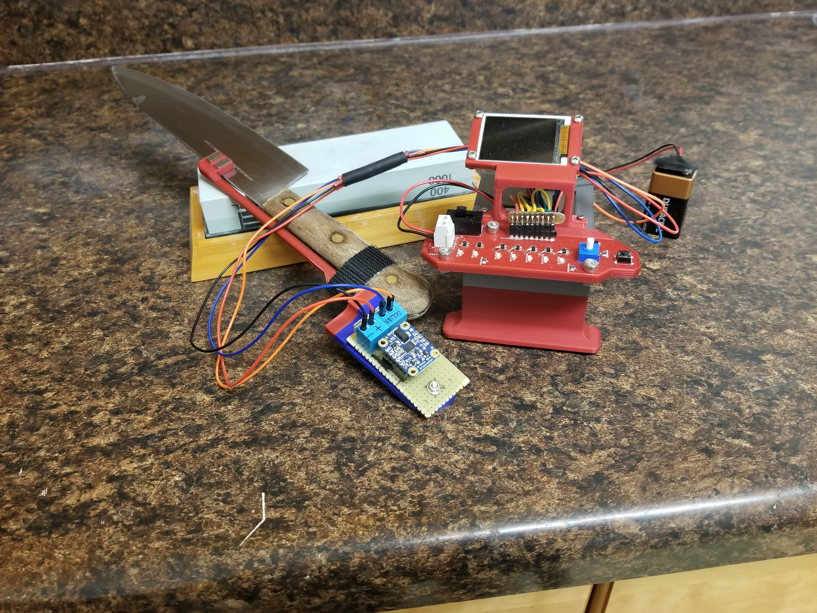Figure 7: Attempt #2. I'm supprised at how sleek the outcome is compared to my first attempt.

## The Reason I Love Math

Do I really need to know what part of the knife touches the grindstone to get an accurate angle?

Since the knife is flat, maybe I could imagine it as a plane? Well, the edge is what's important here, if that doesn't align on a plane… then the knife is just bad. So I can think of the knife as a plane.

I can imagine the BNO055 as a plane as it measures axial tilt, and the Y and Z-axis can be used to create a plane. Since the BNO's YZ-plane is parallel to the knife's plane, I can consider the two planes one and the same.

The grindstone can be considered a flat surface, so that's a plane as well.

So I take two planes, tilt the first one an arbitrary amount and refer that to the second plane. If I translate the first plane in any direction, the angle between the two planes does not change. If I rotate the first plane around either its own or the second plane's perpendicular vector then the angle doesn't change either.

Since the only factor that affects the angle between two planes is tilt, then I don't need to know where the knife touches the grindstone.

I've got a working theory… but how do I find an angle in 3D space?

### Making Discoveries

Made a quick search “how to find the angle between two vectors,” finding the angle between two planes formula instead. I initially didn't think that was what I needed, I noted the formula down anyway. Ok, the BNO outputs its orientation as axial rotations, “how to find vector position from rotations” [or something like that]; Stackoverflow post “Definition - How Would You Define a 3d Angle?”, user H. H. gave an entire article on the subject, though the best lead I found was the section on rotation mairecies with no equations. (*“Definition - How Would You Define a 3d Angle?”,* reply by user H. H.)10.

Whist mulling and playing around with rotations, I realized if I tracked the start and ending location of three unit vectors *i*, *j*, and *k* — each pointing along positive X, Y, and Z respectively, rotated them $\frac{π}{2}$; and as I realized later $π$, on an axis, I could represent the resulting transformation as a change in either sine or cosine. I represented all the results as a 3×3 matrix, then multiplied it by a 3×1 i, j, k, giving me rotation matrices for each axis. Although I had the required formulas, I very, very quickly realized that the BNO’s output often mismatches with the rotations I made, as well as using the correct vectors for the angle calculation.

Table 1: Rotate X-axis by 90 degrees.

|  |  |  |  |  |  |  |  |  |  |
| --- | --- | --- | --- | --- | --- | --- | --- | --- | --- |
| $$R_{X}\left(\frac{π}{2}\right)$$ | X | Y | Z | X’ | Y’ | Z’ | X’ | Y’ | Z’ |
| *i* | 1 | 0 | 0 | 1 | 0 | 0 | X | 0 | 0 |
| *j* | 0 | 1 | 0 | 0 | 0 | 1 | 0 | $$cos\left(\frac{π}{2}\right)$$ | $$Ysin\left(\frac{π}{2}\right)$$ |
| *k* | 0 | 0 | 1 | 0 | -1 | 0 | 0 | $$−Zsin\left(\frac{π}{2}\right)$$ | $$cos\left(\frac{π}{2}\right)$$ |

Table 2: Rotate X-axis by 180 degrees.

|  |  |  |  |  |  |  |  |  |  |
| --- | --- | --- | --- | --- | --- | --- | --- | --- | --- |
| $$R_{X}\left(π\right)$$ | X | Y | Z | X’ | Y’ | Z’ | X’ | Y’ | Z’ |
| *i* | 1 | 0 | 0 | 1 | 0 | 0 | X | 0 | 0 |
| *j* | 0 | 1 | 0 | 0 | 0 | 1 | 0 | $$Ycos\left(π\right)$$ | $$sin\left(π\right)$$ |
| *k* | 0 | 0 | 1 | 0 | -1 | 0 | 0 | $$sin\left(π\right)$$ | $$Zcos\left(π\right)$$ |

$$\left[\begin{aligned}x \\ 0 \\ 0\end{aligned}\begin{aligned}0 \\ ycosθ \\ −zsinθ\end{aligned}\begin{aligned}0 \\ ysinθ \\ zcosθ\end{aligned}\right]$$

Equation $\left[\begin{aligned}x \\ 0 \\ 0\end{aligned}\begin{aligned}0 \\ ycosθ \\ −zsinθ\end{aligned}\begin{aligned}0 \\ ysinθ \\ zcosθ\end{aligned}\right]⋅\left[\begin{aligned}i \\ j \\ k\end{aligned}\right]=R_{X}\left(x,y,z,θ\right)=\left[\begin{aligned}xi \\ ycosθj−zsinθk \\ ysinθj+zcosθk\end{aligned}\right]$ 1: Rotation around X-axis.

Table 3: Rotate Y-axis by 90 degrees.

|  |  |  |  |  |  |  |  |  |  |
| --- | --- | --- | --- | --- | --- | --- | --- | --- | --- |
| $$R_{Y}\left(\frac{π}{2}\right)$$ | X | Y | Z | X’ | Y’ | Z’ | X’ | Y’ | Z’ |
| *i* | 1 | 0 | 0 | 0 | 0 | -1 | $$cos\left(\frac{π}{2}\right)$$ | 0 | $$−Xsin\left(\frac{π}{2}\right)$$ |
| *j* | 0 | 1 | 0 | 0 | 1 | 0 | 0 | Y | 0 |
| *k* | 0 | 0 | 1 | 1 | 0 | 0 | $$Zsin\left(\frac{π}{2}\right)$$ | 0 | $$cos\left(\frac{π}{2}\right)$$ |

Table 4: Rotate Y-axis by 180 degrees

|  |  |  |  |  |  |  |  |  |  |
| --- | --- | --- | --- | --- | --- | --- | --- | --- | --- |
| $$R_{Y}\left(π\right)$$ | X | Y | Z | X’ | Y’ | Z’ | X’ | Y’ | Z’ |
| *i* | 1 | 0 | 0 | 0 | 0 | -1 | $$Xcos\left(π\right)$$ | 0 | $$sin\left(π\right)$$ |
| *j* | 0 | 1 | 0 | 0 | 1 | 0 | 0 | Y | 0 |
| *k* | 0 | 0 | 1 | 1 | 0 | 0 | $$sin\left(π\right)$$ | 0 | $$Zcos\left(π\right)$$ |

$$\left[\begin{aligned}xcosθ \\ 0 \\ zsinθ\end{aligned}\begin{aligned}0 \\ ycosθ \\ 0\end{aligned}\begin{aligned}−xsinθ \\ 0 \\ zcosθ\end{aligned}\right]$$

Equation $\left[\begin{aligned}xcosθ \\ 0 \\ zsinθ\end{aligned}\begin{aligned}0 \\ ycosθ \\ 0\end{aligned}\begin{aligned}−xsinθ \\ 0 \\ zcosθ\end{aligned}\right]⋅\left[\begin{aligned}i \\ j \\ k\end{aligned}\right]=R_{Y}\left(x,y,z,θ\right)=\left[\begin{aligned}xcosθi+zsinθk \\ yj \\ −xsinθi+zcosθk\end{aligned}\right]$ 2: Rotation around Y-axis.

Table 5: Rotate Z-axis by 90 degrees.

|  |  |  |  |  |  |  |  |  |  |
| --- | --- | --- | --- | --- | --- | --- | --- | --- | --- |
| $$R_{Z}\left(\frac{π}{2}\right)$$ | X | Y | Z | X’ | Y’ | Z’ | X’ | Y’ | Z’ |
| *i* | 1 | 0 | 0 | 0 | 1 | 0 | $$cos\left(\frac{π}{2}\right)$$ | $$Xsin\left(\frac{π}{2}\right)$$ | 0 |
| *j* | 0 | 1 | 0 | -1 | 0 | 0 | $$−Ysin\left(\frac{π}{2}\right)$$ | $$cos\left(\frac{π}{2}\right)$$ | 0 |
| *k* | 0 | 0 | 1 | 0 | 0 | 1 | 0 | 0 | Z |

Table 6: Rotate Z-axis by 180 degrees.

|  |  |  |  |  |  |  |  |  |  |
| --- | --- | --- | --- | --- | --- | --- | --- | --- | --- |
| $$R_{Z}\left(π\right)$$ | X | Y | Z | X’ | Y’ | Z’ | X’ | Y’ | Z’ |
| *i* | 1 | 0 | 0 | 0 | 1 | 0 | $$Xcos\left(π\right)$$ | $$sin\left(π\right)$$ | 0 |
| *j* | 0 | 1 | 0 | -1 | 0 | 0 | $$sin\left(π\right)$$ | $$Ycos\left(π\right)$$ | 0 |
| *k* | 0 | 0 | 1 | 0 | 0 | 1 | 0 | 0 | Z |

$$\left[\begin{aligned}xcosθ \\ −ysinθ \\ 0\end{aligned}\begin{aligned}xsinθ \\ ycosθ \\ 0\end{aligned}\begin{aligned}0 \\ 0 \\ z\end{aligned}\right]$$

Equation $\left[\begin{aligned}xcosθ \\ −ysinθ \\ 0\end{aligned}\begin{aligned}xsinθ \\ ycosθ \\ 0\end{aligned}\begin{aligned}0 \\ 0 \\ z\end{aligned}\right]⋅\left[\begin{aligned}i \\ j \\ k\end{aligned}\right]=R_{Z}\left(x,y,z,θ\right)=\left[\begin{aligned}xcosθi−ysinθj \\ xsinθi+ycosθj \\ zk\end{aligned}\right]$ 3: Rotation around Z-axis.

From my initial tests of the BNO, I associated each side of the sensor to an axis. Starting from the output [0, 0, 0] and rotating to isolate each axis, The face aligns with the x-axis, the long edge with y, and the short edge with the z-axis. Though, now paying closer attention, rotating the sensor around two of its axis, the output would often mismatch from the rotations I made; so let’s say z then x both at $\frac{π}{2}$, the BNO would instead output of [$\frac{π}{2}$, $\frac{π}{2}$, 0].

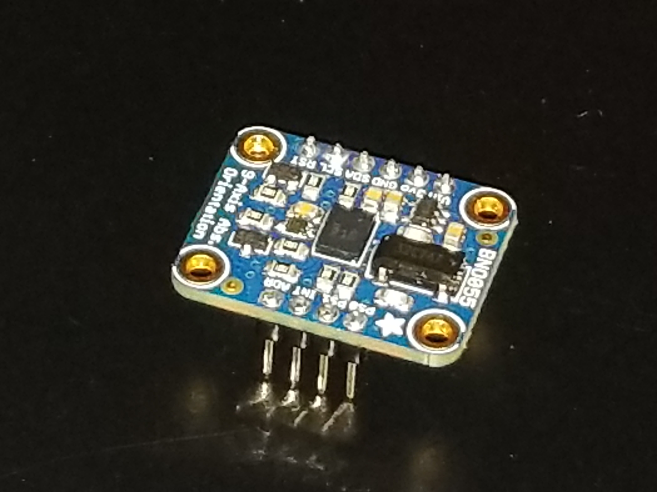Figure 8: The BNO055.

Humoring that the BNO’s output was still correct, I physically rotated the sensor and plugged the output into my equations. Performing RY() then RX() both physically and through calculations, both result in the BNO facing the same direction. Therefore, the BNO055 calulates its output from the fixed axis oriented at [0, 0, 0]. I’ll reffer to the fixed axis as the global axis with X, Y, and Z; the axis aligning with the sensor will be object axis x, y, and z. Order of axial rotation matters, reversing RXθ→RYθ results in a different orientation from RYθ→RXθ.

So… then what’s the BNO’s order of rotation? Again, I returned to rotating the sensor around, performed $\frac{π}{2}$ rotation around Z then X-axis noticing that the output showed $\left[\frac{π}{2},0,\frac{π}{2}\right]$— the output matched the rotations I made. So the best option was to test every single two-step $\frac{π}{2}$ rotation and record the results as seen in the chart below.

Table 7: BNO055 output for all two-step 90 degree rotations

|  |  |  |
| --- | --- | --- |
| Global Rotations | Object Rotations | Output |
| $$R_{Z}\left(\frac{π}{2}\right)→R_{X}\left(\frac{π}{2}\right)$$ | $$R_{z}\left(\frac{π}{2}\right)→R_{y}\left(\frac{π}{2}\right)$$ | $$\left[\frac{π}{2},0,\frac{π}{2}\right]$$ |
| $$R_{X}\left(\frac{π}{2}\right)→R_{Z}\left(\frac{π}{2}\right)$$ | $$R_{x}\left(\frac{π}{2}\right)→R_{y}\left(\frac{π}{2}\right)$$ | $$\left[\frac{π}{2},\frac{π}{2},0\right]$$ |
| $$R_{Y}\left(\frac{π}{2}\right)→R_{Z}\left(\frac{π}{2}\right)$$ | $$R_{y}\left(\frac{π}{2}\right)→R_{x}\left(\frac{π}{2}\right)$$ | $$\left[\frac{−π}{2},0,\frac{π}{2}\right]$$ |
| $$R_{Z}\left(\frac{π}{2}\right)→R_{Y}\left(\frac{π}{2}\right)$$ | $$R_{z}\left(\frac{π}{2}\right)→R_{x}\left(\frac{π}{2}\right)$$ | $$\left[\frac{π}{2},\frac{π}{2},0\right]$$ |
| $$R_{Y}\left(\frac{π}{2}\right)→R_{X}\left(\frac{π}{2}\right)$$ | $$R_{y}\left(\frac{π}{2}\right)→R_{z}\left(\frac{π}{2}\right)$$ | $$\left[\frac{π}{2},\frac{π}{2},0\right]$$ |
| $$R_{X}\left(\frac{π}{2}\right)→R_{Y}\left(\frac{π}{2}\right)$$ | $$R_{x}\left(\frac{π}{2}\right)→R_{z}\left(\frac{π}{2}\right)$$ | $$\left[\frac{π}{2},0,−\frac{π}{2}\right]$$ |

As shown, both $R_{Y}\left(\frac{π}{2}\right)→R_{X}\left(\frac{π}{2}\right)$ and $R_{Z}\left(\frac{π}{2}\right)→R_{X}\left(\frac{π}{2}\right)$ rotations match their respective outputs; since rotation order matters and X-axis rotation came last both times, I figured that X-axis came last in the rotation calculation. Now scanning through the outputs, $R_{X}\left(\frac{π}{2}\right)→R_{Z}\left(\frac{π}{2}\right)$, $R_{Z}\left(\frac{π}{2}\right)→R_{Y}\left(\frac{π}{2}\right)$, and $R_{Y}\left(\frac{π}{2}\right)→R_{X}\left(\frac{π}{2}\right)$ all end up with an orientation of $\left[\frac{π}{2},\frac{π}{2},0\right]$. I already accounted for $R_{Y}\left(\frac{π}{2}\right)→R_{X}\left(\frac{π}{2}\right)$, $R_{X}\left(\frac{π}{2}\right)→R_{Z}\left(\frac{π}{2}\right)$ can be ignored as RXθ should come last. Leftover, $R_{Z}\left(\frac{π}{2}\right)→R_{Y}\left(\frac{π}{2}\right)$, the order of rotation calculation is RX(RY(RZθ))).

To test out my theory, I wrote out and set up all three rotation matrices into Desmos Graphing calculator and then performed the following three axis rotation on the BNO: with vector [1, 0, 0], perform RZ()→RY()→RX(). The sensor output $\left[\frac{2π}{3},\frac{π}{2},0\right]$. I plugged in both my three-step rotation and the sensor’s output into my rotation formula, both equateing to $\left[0,.866,.5\right]$— I’ve got myself a winner!

### Which way is Up?

Second concern: what vector should I use to calculate the angle? See, my first idea used an arbitrary vector within the YZ-plane of the knife and the grindstone as, initially, it made complete sense: compare the two YZ-planes with vectors within said planes. Paused, gave it some more thought… If I were to rotate either of the planes around their x-axis and stick with the same vectors, the resulting calculation will change even though the planes never changed their tilt respective to each other. And recalculating the proper vector would be a huge pain to figure out.

Alright, let’s hope someone on the internet solved that for me. So I happened to pull up on a tutorial on planes written by Song Ho Ahn (songho.ca) from their notes; reading under the intersection between two planes, and lo and behold they used the vector normal to each plane in the formula instead. As I read on, using the normal vectors still fits the requirements of needing two vectors perpendicular to the line on intersection, and it won't change position if the plane rotates around its normal axis. Perfect, perfect, perfect! I could use the vector [1, 0, 0] to find the angle between the two YZ-planes, plugged — and reduced — the rotation formula into the code soon after and outcomes some damn accurate angles. Hoooooo, nothing hits like finally solving a tough problem.

$$R_{Z}\left(1,0,0,θ_{Z}\right)=\left[\begin{aligned}cosθ_{Z}i−0sinθ_{Z}j \\ sinθ_{Z}i+0cosθ_{Z}j \\ zk\end{aligned}\right]=\left[\begin{aligned}cosθ_{Z}i \\ sinθ_{Z}i \\ 0\end{aligned}\right]$$

$$R_{Y}\left(R_{Z},θ_{Y}\right)=\left[\begin{aligned}\left(cosθ_{Z}i\right)cosθ_{Y}i+0sinθ_{Y}k \\ \left(sinθ_{Z}i\right)j \\ −\left(cosθ_{Z}i\right)sinθ_{Y}i+0cosθ_{Y}k\end{aligned}\right]=\left[\begin{aligned}\left(cosθ_{Z}i\right)cosθ_{Y}i \\ \left(sinθ_{Z}i\right)j \\ −\left(cosθ_{Z}i\right)sinθ_{Y}i\end{aligned}\right]$$

$$R_{X}\left(R_{Y},θ_{X}\right)=\left[\begin{aligned}\left(\left(cosθ_{Z}i\right)cosθ_{Y}i\right)i \\ \left(\left(sinθ_{Z}i\right)j\right)cosθ_{X}j−\left(−\left(cosθ_{Z}i\right)sinθ_{Y}i\right)sinθ_{X}k \\ \left(\left(sinθ_{Z}i\right)j\right)sinθ_{X}j+\left(−\left(cosθ_{Z}i\right)sinθ_{Y}i\right)cosθ_{X}k\end{aligned}\right]$$

Equation $R_{X}\left(R_{Y}\left(R_{Z}\left(1,0,0,θ_{Z}\right),θ_{Y}\right),θ_{X}\right)=\left[\begin{aligned}cosθ_{Z}cosθ_{Y}i^{3} \\ sinθ_{Z}cosθ_{Y}{ij}^{2}+cosθ_{Z}sinθ_{Y}sinθ_{X}i^{2}k \\ sinθ_{Z}sinθ_{Y}{ij}^{2}−cosθ_{Z}sinθ_{Y}cosθ_{X}i^{2}k\end{aligned}\right]$ 4: Reduced rotation matrix using vector [1, 0, 0].

# Revisiting, if I Felt like it

Designed a super simple case, soldered all the components and wires together. It’s done, and it works. And my mind is already drifting to a V2. I’m not about to go back any time soon… I think, but if I’m so inclined, or you dear reader, would like to make improvements.

The five LEDs signaling how off the knife’s angle from the desired angle takes up a port for each LED. The total number of states they can be in is nine — five to light up each LED individually and 4 for each two adjacent pairs — allowing all states to fit within 4 bits, leaving 6 bits of numbers unused. Maximizing the number of LEDs used then would result in soldering 8 of them, 8 singles and 7 adjacent pairs.

Most of the project can easily be minimized to a single PCB: design a new circuit to connect an Arduino mini, or some other small microcontroller, and the control panel on a single PCB. To have a screen mounted on the same PCB is up to preference, keep it in one and the entire board would have to be angled for better viewing. In two, the screen can be moved independently of the main board. Or go nuts or something.

Sending the orientation data over wireless would untether the knife from the Arduino and hopefully help keep water from shorting out the entire circuit. Staying on safety, overvoltage/current protection is a must as well as better waterproofing.

Could always take the next step and automate the grinding. Off the top of my head, whatever robot arm used must be capable of moving the knife along the grindstone (or move the grindstone itself) and needs to keep constant pressurte as it sweeps along the knife’s edge.

That’s pretty much all I got, I dearly thank you reader for your time. Any further questions on this project feel free to send an email, and I’ll do my best to awnser what I can.

# Workd Cited

3D Printing Nerd. “Embedded Magnets Thanks to Flipping Normals!” YouTube, 24 Feb. 2019, www.youtube.com/watch?v=oF1SdIR-Kow. Accessed 24 Oct. 2021.

“Adafruit BNO055 Absolute Orientation Sensor.” Adafruit Learning System, learn.adafruit.com/adafruit-bno055-absolute-orientation-sensor.

“Adafruit Unified Sensor Driver.” GitHub, 22 Oct. 2021, github.com/adafruit/Adafruit_Sensor/blob/master/Adafruit_Sensor.h. Accessed 24 Oct. 2021.

“Definition - How Would You Define a 3d Angle?” Mathematics Stack Exchange, math.stackexchange.com/questions/1828850/how-would-you-define-a-3d-angle/3217965. Accessed 24 Oct. 2021.

EEVblog. “EEVblog #742 - Why Electrolytic Capacitors Are Connected in Parallel.” YouTube, 9 May 2015, www.youtube.com/watch?v=wwANKw36Mjw. Accessed 31 Mar. 2020.

EEVblog. “EEVblog #997 - How to Solder Surface Mount Components.” YouTube, 2 June 2017, www.youtube.com/watch?v=hoLf8gvvXXU. Accessed 24 Oct. 2021.

EEVblog. “EEVblog #1323 - PCB Layout Review & Analysis.” YouTube, 24 July 2020, www.youtube.com/watch?v=xhRhsCVF8mE. Accessed 24 Oct. 2021.

Feranec, Robert. “How to Improve Your PCB Layout - Routing & Space.” YouTube, 27 Aug. 2020, www.youtube.com/watch?v=YRDZ2Vn_6J4. Accessed 24 Oct. 2021.

Feranec, Robert. “PCB Layout & Decoupling - Explained Why It’s so Complicated (Part 1).” YouTube, 10 Sept. 2020, www.youtube.com/watch?v=5Ca0Eah7eKI. Accessed 24 Oct. 2021.

Feranec, Robert. “Is KiCad Ready to Replace Paid PCB Design Software? (with Wayne Stambaugh).” YouTube, 17 Dec. 2020, www.youtube.com/watch?v=6qcsJfoqbL4.

GreatScott. “How to Solder Properly || Through-Hole (THT) & Surface-Mount (SMD).” YouTube, 3 Sept. 2017, www.youtube.com/watch?v=VxMV6wGS3NY. Accessed 24 Oct. 2021.

“Plane Equation.” Www.songho.ca, www.songho.ca/math/plane/plane.html. Accessed 24 Oct. 2021.

# Contact Information

Email: jasonkeene145@gmail.com

LinkedIn: www.linkedin.com/in/jason-keene-967997171

# Project Information

GitHub: <https://github.com/JasonKeene7/Knife-Sharpening-Guide>

YouTube: <https://www.youtube.com/channel/UC3k1618slugnFINNf2hE3oQ>